**Worksheet #1**

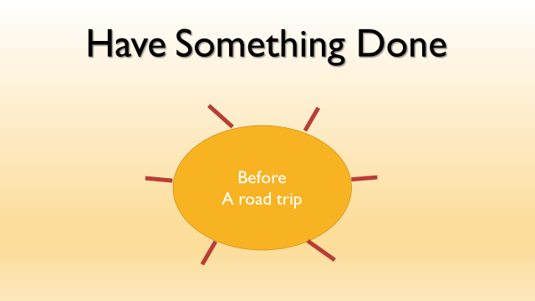

**Make a list 5 things before you take a road trip by using have Something Done**

**1.**

**2.**

**3.**

**4.**

**5**

**Worksheet #2**

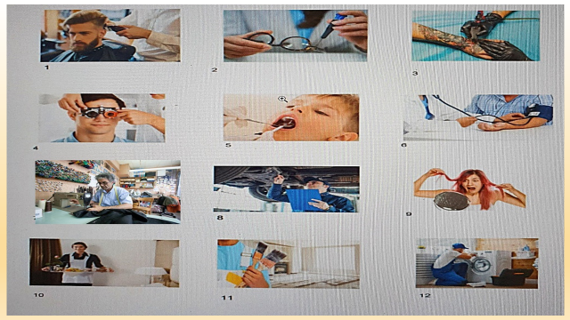

**Worksheet #3**

Survey

Write questions about your classmates by using “Have Something done” and write their answers.

|  |  |  |  |  |
| --- | --- | --- | --- | --- |
| **Question** | **Name:** | **Answer** | **Name** | **Answer** |
| 1. **When was the last time you had ?** |  |  |  |  |
| 1. **If you had more money would you pay to have your house ?** |  |  |  |  |
| 1. **Be honest, have you ever ___________ ?** |  |  |  |  |
| 1. **Have you ever have your wallet ?** |  |  |  |  |
| 1. **If you rip or tear your clothes do you usually go to a tailor to have ?** |  |  |  |  |
| 1. **How often do you have your teeth ?** |  |  |  |  |
| 1. **Have you ever had ___ ?)** |  |  |  |  |
| 1. **When was the last time you ha** |  |  |  |  |